**Updated Child Photos   
July 2018**

**Took Photo E-mailed to Teri**

1. Abreham Kuba _____ _____
2. ~~Abreham Tefera _____ _____~~
3. ~~Bereket Tamerat _____ _____~~
4. ~~Beruk Gemechu _____ _____~~
5. ~~Beselote Dega _____ _____~~
6. Besufekad Yohannes _____ _____
7. Bleane Girma _____ _____
8. Dawit Leda Bedada _____ _____
9. Eayasu Wondimu _____ _____
10. ~~Efrata Mesenbet Ketema _____ _____~~
11. ~~Elshadye Belete _____ _____~~
12. ~~Genet Mamo Bune _____ _____~~
13. Hana Kebede Kefeni _____ _____
14. ~~Kaleb Godana _____ _____~~
15. ~~Kalkidan Kebede Kefeni _____ _____~~
16. ~~Meheret Efrem _____ _____~~
17. ~~Mistre Kebede Kefeni _____ _____~~
18. ~~Natnael Teshome _____ _____~~
19. ~~Semira Adem _____ _____~~
20. ~~Sentayehu Gemechu _____ _____~~
21. Tsedanya Alemayhu _____ _____
22. Yabsira Alemayehu _____ _____
23. ~~Yabsira Feseha _____ _____~~
24. Yosef Getachew _____ _____
25. ~~Yosef Tesfaye _____ _____~~

**EXCELLENT PHOTOS**

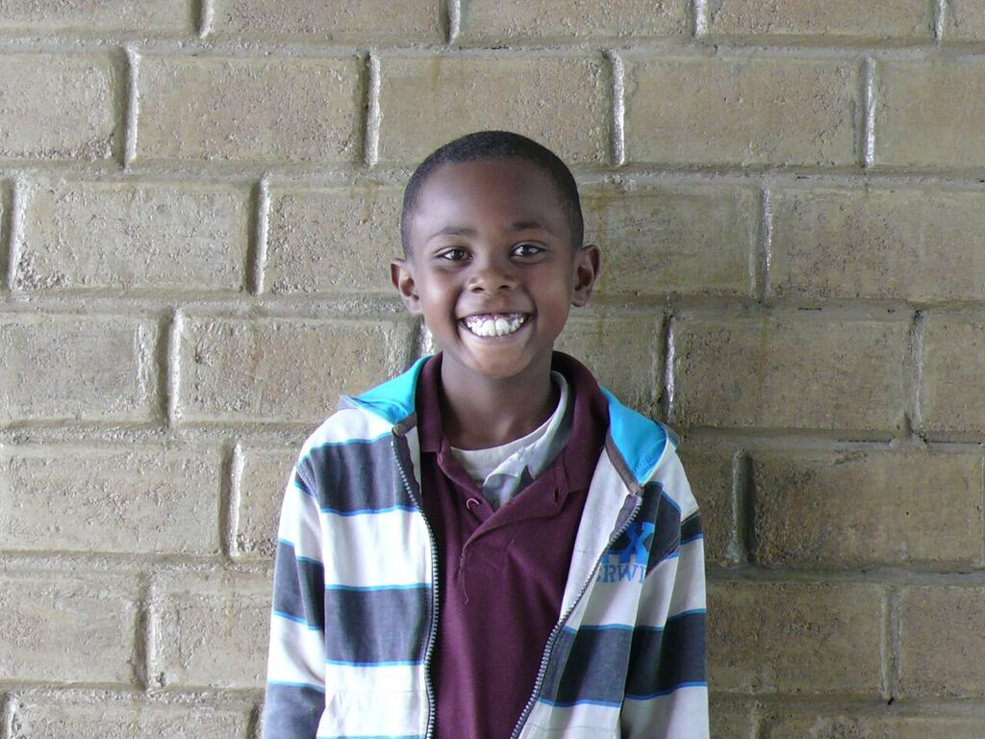 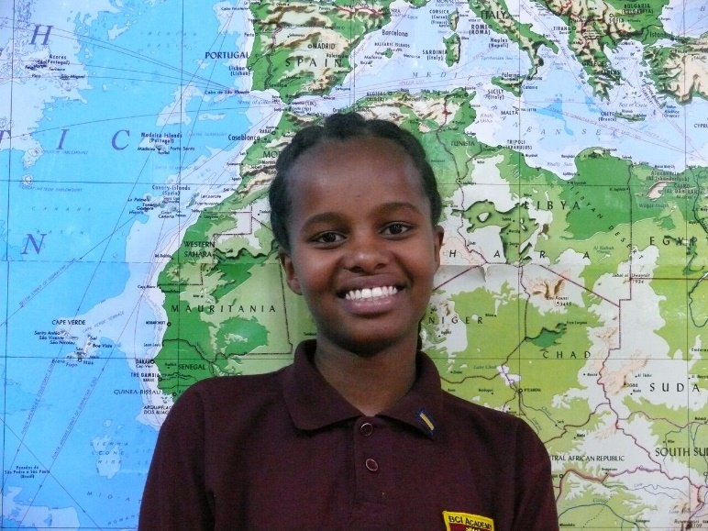

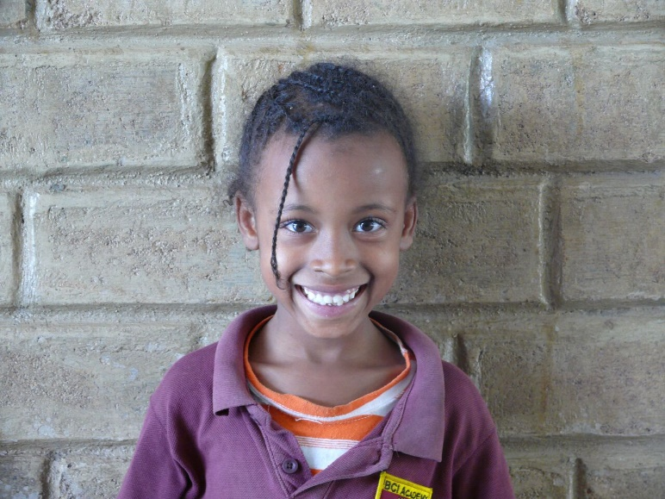 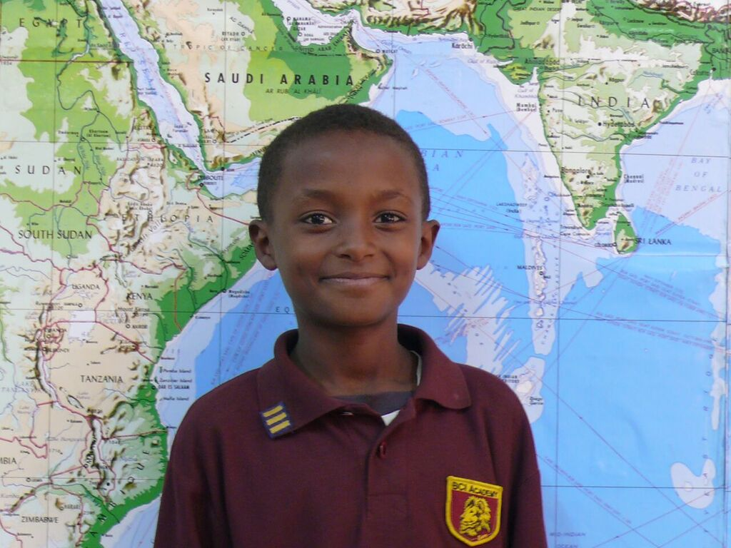

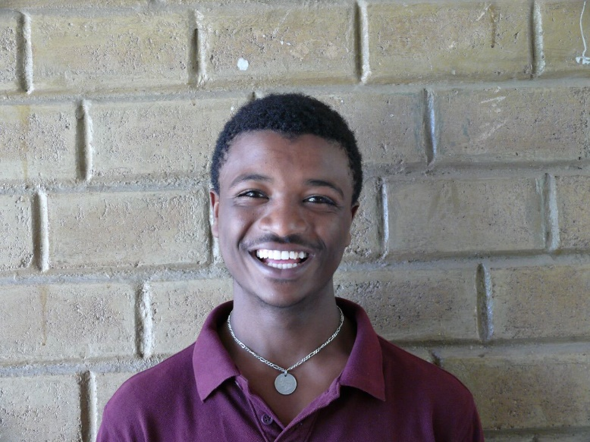 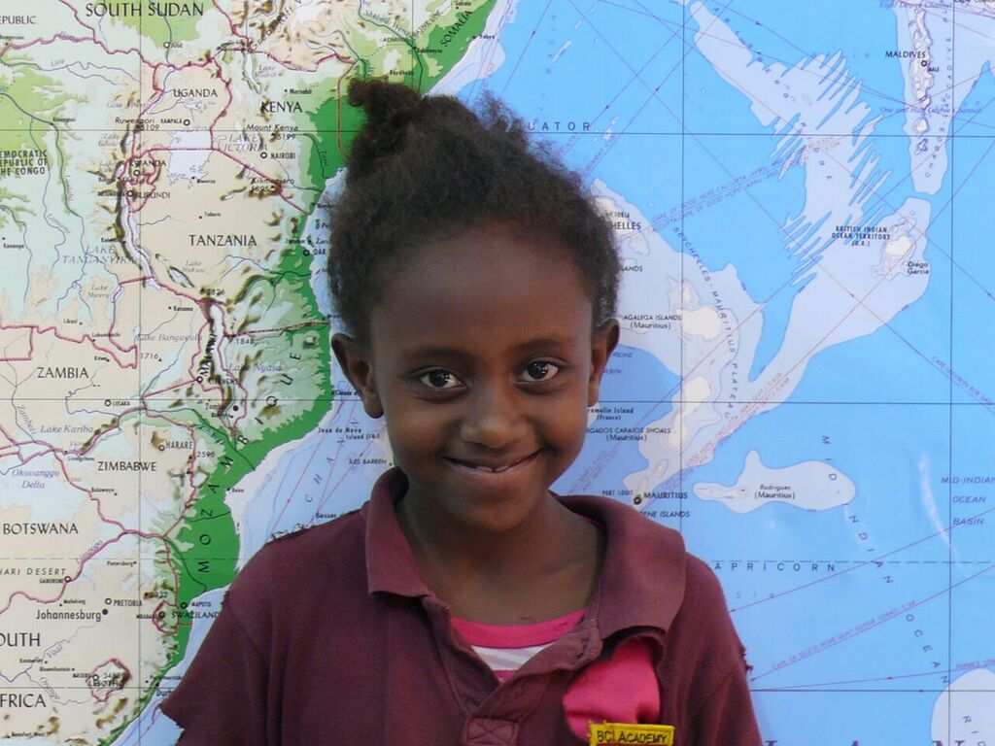

**Map is the best background. Brick is second choice. In all of these photos the lighting is good, they have warm smiles, and the photos are clear with good quality.**

**TOO SERIOUS – NEED TO SMILE**

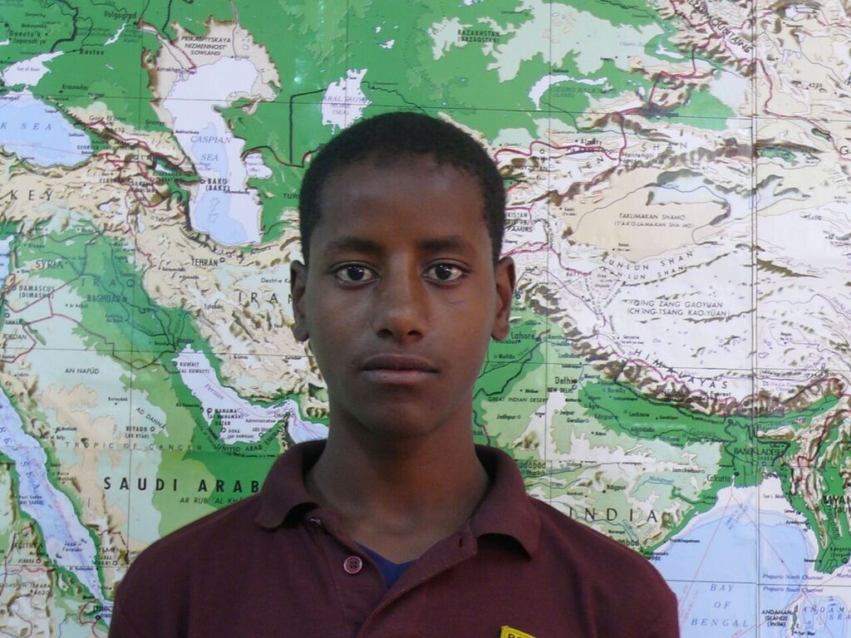 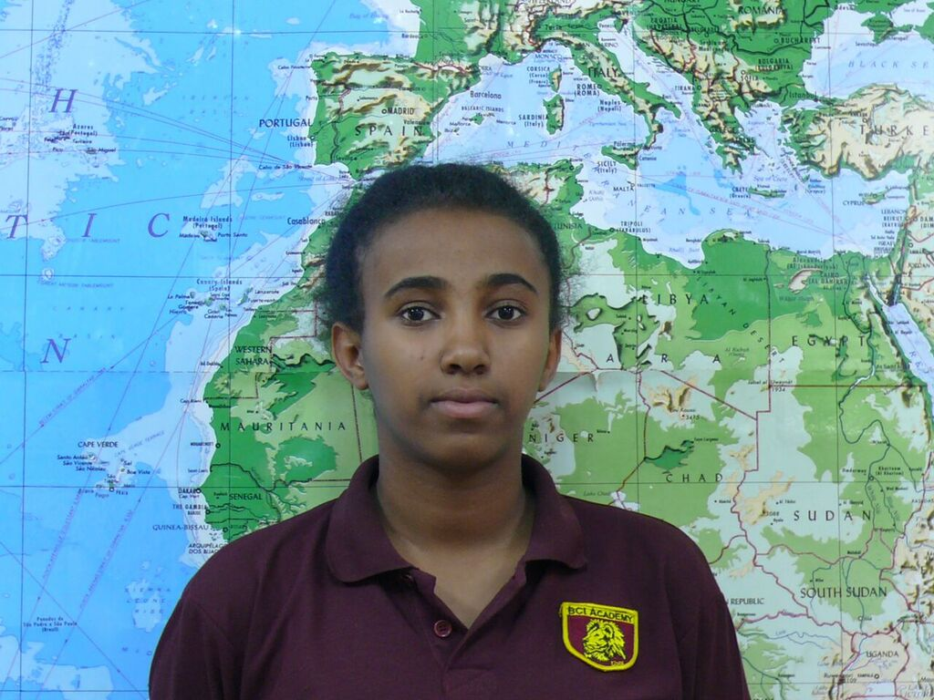

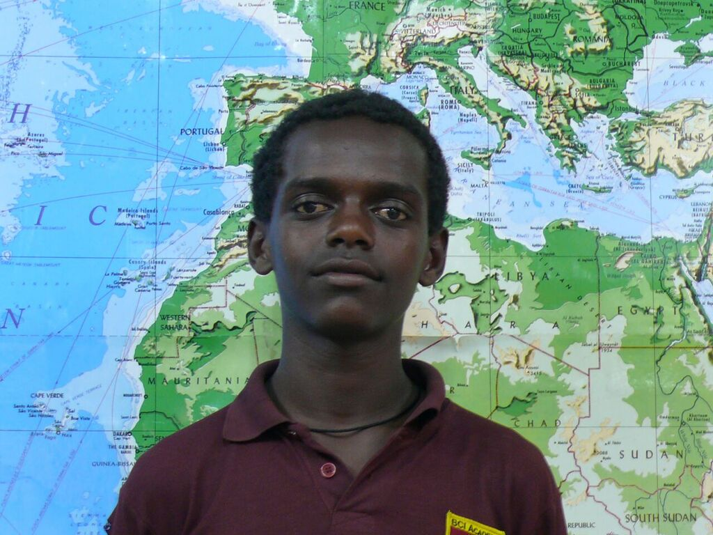

**SHADOWS / LIGHTING IS NOT GOOD**

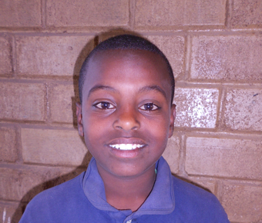 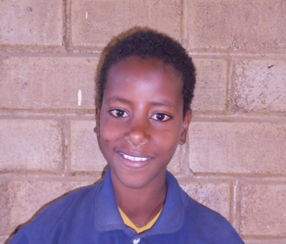

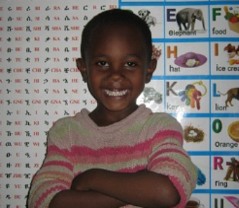

**NEED TO LOOK AT THE CAMERA**

